FILE HANDLING / FILE OPERATIONS /DATA FILES
File is the name of physical memory location within secondary storage area that is hard disk.
In implementation, when we need to read or write the data from the secondary storage area, then go for file operations. By using file operations related data can be stored permanently in the secondary storage area. Whenever we want to load this information from secondary storage area then also we can use file operations.
I/O operations are classified into 2 types.
1. Standard I/O operations.
2. Secondary I/O operations
When we are interacting with standard I/O devices then it is called standard I/O operations. when we are interacting with secondary I/O devices, then it is called secondary I/O operations.
Standard I/O and Secondary I/O related operations are controlled by <stdio.h>
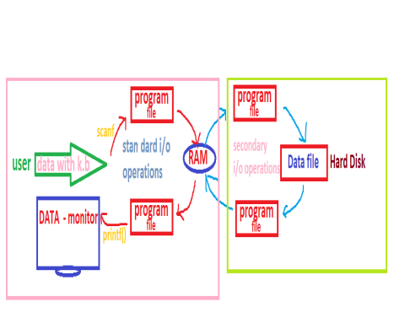In C, to control file operations, we are using predefined structure called FILE.
FILE structure size is 16 bytes.
It need pointer structure variable.
fopen(): It is used to open a file in specified mode. If file is not opened, it returns NULL.
Syntax: fopen(filename, mode);
fputc(): It is used to write a character into the file.
Syntax: fputs(ch, fileptr);
fgetc(): It reads a character from file.
Syntax: fgetc(fileptr);
fwrite(): It is used to write the data into a data file.
Syntax: fwrite(&var,noofbytes,nooftimes, fileptr);
fread(): It is used to read the data from a data file.
Syntax: fread(&var,noofbytes,nooftimes, fileptr);
fclose(): It closes the currently opened data file.
Syntax: fclose(fileptr);
fseek(): It is used to move the file pointer to a specified position. Syntax: fseek(fileptr,position, from);
ftell(): It returns the current file pointer position.
Syntax: ftell(fileptr);
rename(): It is used to change the filename.
Syntax: rename(oldfilename, newfilename);
remove(): It deletes a file.
Syntax: remove(filename);
We are conducting two types of file operations. 1. Text file operations, where our data stored in the form of characters.
2. Binary file operations, where our data stored based on the data types.
Eg: creating a data file:
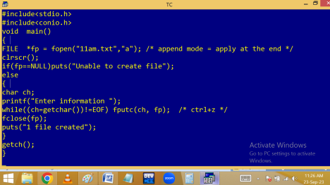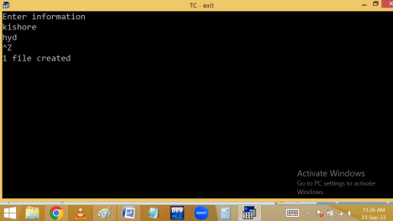Reading the content of a text file:
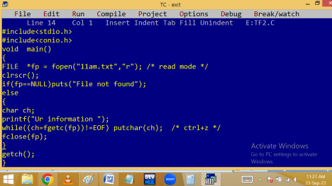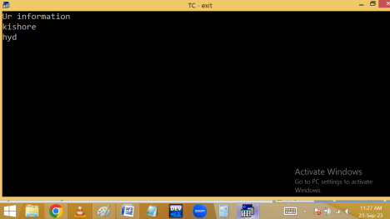Write a c program to display source code as output:
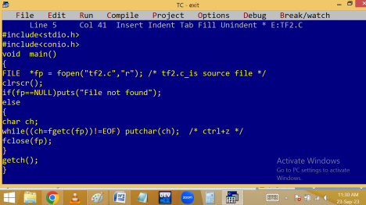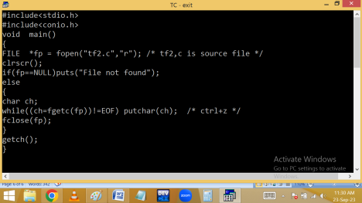
Working with binary files with project: 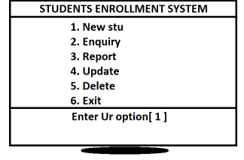#include<stdio.h>
#include<conio.h>
struct stu
{
int id;
char name[20];
}
s;
int idno, found, op;
char ch;
FILE *fp, *t;
void newstu(); /* fun dec */
void enquiry();
void report();
void upd();
void del();
void line()
{
puts("--------------------------------------------------------------------"); }
void main()
{
clrscr();
line();
puts("\t\t\t STUDENTS ENROLLMENT SYSTEM"); line();
puts("\t\t\t 1. New stu");
puts("\t\t\t 2. Enquiry");
puts("\t\t\t 3. Report");
puts("\t\t\t 4. Update");
puts("\t\t\t 5. Delete");
puts("\t\t\t 6. Exit");
line();
printf("\t\t\t Enter Ur option [ ]\b\b"); scanf("%d",&op);
switch(op)
{
case 1:
newstu();
break;
case 2:
enquiry();
break;
case 3:
report();
break;
case 4:
upd();
break;
case 5:
del();
break;
case 6:
return;
default:
puts("Invalid Option");
}
getch();
main(); /* recursion */
}
void newstu() /* fun definition */ {
clrscr();
fp = fopen("11proj.dat","a"); while(1)
{
printf("Enter stu id, name ");
scanf("%d %s",&s.id,s.name);
fwrite(&s,sizeof(s),1,fp);
puts("1 row created");
flushall();
printf("Do you want to continue [y/n] "); scanf("%c",&ch);
if(ch=='n'||ch=='N')
break;
}
fclose(fp);
}
void enquiry()
{
found=0;
clrscr();
fp = fopen("11proj.dat","r"); fread(&s,sizeof(s),1,fp);
printf("Enter stu id to search "); scanf("%d",&idno);
while(!feof(fp))
{
if(idno==s.id)
{
found=1;
puts("Id\tName");
line();
printf("%d\t%s\n",s.id,s.name); break;
}
fread(&s,sizeof(s),1,fp);
}
fclose(fp);
if(found==0)
printf("stu not found");
}
void report()
{
clrscr();
fp = fopen("11proj.dat","r"); if(fp==NULL)
puts("File not found");
else
{
puts("ID\tNAME");
line();
fread(&s,sizeof(s),1,fp);
while(!feof(fp))
{
printf("%d\t%s\n",s.id,s.name); fread(&s,sizeof(s),1,fp);
}
fclose(fp);
}
}
void upd()
{
found=0;
clrscr();
printf("Enter stu id to update ");
scanf("%d",&idno);
fp = fopen("11proj.dat","r+"); /* read and write */ fread(&s,sizeof(s),1,fp);
while(!feof(fp))
{
if(idno==s.id)
{
found=1;
puts("Id\tName");
line();
printf("%d\t%s\n",s.id,s.name);
printf("Enter new id, name ");
scanf("%d %s",&s.id,s.name);
fseek(fp, ftell(fp)-sizeof(s),0); /* 0-current position */ fwrite(&s,sizeof(s),1,fp);
puts("One row updated");
break;
}
fread(&s,sizeof(s),1,fp);
}
fclose(fp);
if(found==0)
puts("Stu not found");
}
void del()
{
found=0;
clrscr();
fp = fopen("11proj.dat","r"); t = fopen("temp","w");
printf("Enter stu id to delete "); scanf("%d",&idno);
fread(&s,sizeof(s),1,fp);
while(!feof(fp))
{
if(idno==s.id)
{
found=1;
puts("Id\tName");
line();
printf("%d\t%s\n",s.id,s.name); }
else fwrite(&s,sizeof(s),1, t); fread(&s,sizeof(s),1,fp);
}
fclose(fp);
fclose(t);
printf("R u sure to delete [y/n] "); flushall();
scanf("%c",&ch);
if(ch=='n'||ch=='N')
puts("Operation cancelled"); else
{
remove("11proj.dat");
rename("temp","11proj.dat"); puts("One row deleted"); }
}

